
T.A.B.S.
TAX – ACCOUNTING – BOOKKEEPING
PROFESSIONALS

Dear W-2 Employee:

Thank you for choosing T.A.B.S., Inc., to prepare your income tax returns. Please read the enclosed information carefully. Please complete and return the enclosed Client Information Sheet. If you do not send us all of the information requested, the preparation of your tax returns will be delayed.

A link for the IRS form 2848, Power of Attorney is on the packet home page. This form is only for income tax purposes only. It authorizes T.A.B.S., Inc., to discuss tax matters with the IRS or to sign your tax return in your absence. If you are filing a joint return, please include both names and social security numbers on line 1 of the Power of Attorney and be sure that both taxpayers sign on line 9. Please do not sign Part II. Without a signed, original Power of Attorney in our office, we will not be able to act on your behalf. Please note, that the Power of Attorney allows us to sign your returns but we will not do so unless you request it. Due to additional fees involved when correspondence or paperwork is sent to the IRS, we do not automatically use the Power of Attorney that is in your file. All mailing from this office to the IRS is sent certified, return receipt.

Your tax information can be sent to us via the client portal, email or mail. We will review this information and contact you with any questions we may have. It is not necessary, but sometimes helpful, to meet with a tax return preparer. Please call our receptionist to schedule an appointment if you feel it necessary. Our office hours are listed below:

April 16 – January 15
Monday – Thursday 9:00 A.M. to 4:00 P.M. (Appointment Preferred)

January 16 – April 15
Monday – Friday 8:30 A.M. to 5:00 P.M. (Appointment Only)
Saturday 9:00 A.M. to 1:00 P.M. (Appointment Only)

If you have any questions regarding the firm, please call during business hours and someone will be able to assist you.

609 INDEPENDENCE PARKWAY – SUITE 120
CHESAPEAKE, VA 23320
757-436-3150 (phone) – 757-436-8099 (fax)
info@tabtax.com (email)
www.tabtax.com
https://tabs.cchifirm.us

PAYMENT/FILING POLICIES

Our Billing rates are based on time spent in preparation of your return (rather than a percentage of your refund) and may include charges for Priority Mail and long distance phone calls. Our rates are competitive with other small accounting firms.

Returns are processed in the order that they are received. If you are filing multiple years, a deposit of at least one year’s fee is required before we start processing the returns. Please be sure to include a payment when mailing in your returns to avoid delays in processing. Returns must be paid in full before T.A.B.S. can release your information either to you or to the government and other taxing authorities.

All returns will be e-filed according to IRS requirements. You will need to review your return and sign the e-file consent form prior to filing. We will notify you if there is a problem with your e-file. Copies of your returns will be uploaded to your client portal.

If your tax return information has not arrived in our office by April 1st then we will send out an automatic six month extension of time to file the tax return for you. Please notify our office if you do not want us to submit the extension on your behalf. Please note this extension is not an extension of time to pay any balance due on your return. To avoid penalty and interest assessed please make certain you have paid both the IRS and your state at least 90% of the tax that was due on the previous year’s return.

If you anticipate leaving the country before your tax return has been completed, we suggest you make arrangements for payment and filing of your returns with a relative. Please let us know with whom these arrangements have been made so that we can expedite the filing process.

Payment can be made via credit card, check, money order, and cash. We reserve the right to hold your tax return for 10 business days if you pay by check. Please be advised there will be a $35 charge for a returned check. We also require the 3 or 4 digit verification number and the billing zip-code for credit card payments.

If you refer 5 people and they become clients, you will receive a free tax return. New clients, provide this information on the Client Information Sheet. It is important that you indicate who referred you to our firm. If you have any questions regarding our Payment/ Filing Policies, please contact the office.

GENERAL FEES

Bookkeeping: $55.00 per hour. For new clients we will start you off on an hourly basis for a month or two to get a base line for you. All clients will be moved to a set fee per month. If we travel to your office we will be setting you up with a specific day per month for bookkeeping services.

Incorporation: Our fee for Incorporations is $570.00. This fee does include your filing fee to the state. Our firm will obtain your state certificate, Federal ID number, S Corp. election if need be, and prepare a corporate book and stock certificates for you. Please be aware that most states also have an annual fee or franchise tax forms that may need to be filled out. Once we have incorporated you it will be your responsibility to make sure these forms are filed timely. We will be happy to offer you additional assistance if needed. Dissolutions of corporations will be billed at $200 plus state filing fees.

Payroll: Our firm will charge an initial set up fee of $125.00 to set up and complete all the necessary government forms for your payroll. For payrolls with five or fewer people the fee is $260.00 per quarter. The fee for payroll with six to ten employees is $320.00 per quarter and the fee for ten to twenty employees is $420.00 per quarter. This fee includes your payroll calculations, state and federal calculations and your payroll reports. If we need to fill out or print checks for you please add an additional $1.00 FEE PER CHECK. The W2 and 1099 forms will be billed separately at $7.00 per form. The year end summary will continue to be billed at the bookkeeping rate per hour.

Tax returns: Tax return rates vary per return. However, in general a basic corporate return will be a minimum of $570.00. Independent Contractor returns run around $540.00 for federal and state returns. This fee includes the IRS mandatory electronic filing. Personal returns for our Corporation Clients run between $275.00 and $375.00 per return. This fee also includes the IRS mandatory electronic filing. For all other returns the average fee is $275.00 for a Federal and State return. However, please remember that your fees will vary due to the differing nature of each return. We do not provide RALS.

Mortgage letters: We will be happy to help you with your mortgage. Most lenders now require a letter from a CPA. We charge a $55.00 fee to cover the time and postage for these letters.

Any check returned to our firm will incur a $35.00 charge.

There is no charge for initial consultations. Tax planning, additional meetings and letters will be billed at an hourly rate of $75.00 per hour.

Any check returned to our firm will incur a $35 charge.

If you have any questions please do not hesitate to contact us.

TAX PREPERATION CONSENT

I hereby engage T.A.B.S., Inc. to prepare my income tax returns.

I understand that the returns will be prepared from information that I provide. I represent that I have the required substantiation for all such information.

T.A.B.S., Inc. is not engaged to audit or verify information that I provide. However, I understand that T.A.B.S., Inc. may ask for clarification of certain items.

I understand that I will be billed for services upon completion of the engagement. I agree to pay upon receipt of invoice, subject to a service charge of 1 1/2% per month on any outstanding balance including attorney’s fees of 25%.

I have read and agree to the Payment Filing Policies and The General Fees. If TABS has had no response from me regarding my returns, by the filing due date, then I authorize TABS to run the payment information I provided and file the returns on my behalf.

If I am claiming the Foreign Income Exclusion then I have read the pertinent information, including court cases, and I acknowledge that I qualify for this income exclusion per IRS rules and regulations.

I am aware that additional services, such as tax planning, estate planning, responding to IRS notices, representation before tax authorities and assistance during an audit of my return are available to me. However, the cost of these services is not included in the fee for the preparation of my income tax return.

Signed: _____________________________________________________

On _________________________of _______________________, 20___

IMPORTANT NOTE AS REQUIRED BY THE IRS

TO ENSURE COMPLIANCE WITH REQUIREMENTS IMPOSED BY THE
IRS ON ALL TAX ADVISORS WHO ADVISE CLIENTS ON FEDERAL
TAX ISSUES, WE ARE REQUIRED TO INFORM YOU THAT ANY U.S.
FEDERAL TAX ADVICE CONTAINED IN THIS COMMUNICATION
(INCLUDING ANY ATTACHMENTS) IS NOT INTENDED OR WRITTEN
TO BE USED, AND CANNOT BE USED, FOR THE PURPOSE OF
(I) AVOIDING PENALTIES UNDER THE INTERNAL REVENUE CODE OR (II) PROMOTING, MARKETING OR RECOMMENDING TO ANOTHER PARTY ANY TRANSACTION OR MATTER ADDRESSED HEREIN. THIS ADVICE MAY NOT BE FORWARDED WITHOUT OUR EXPRESS WRITTEN CONSENT.

Foreign Income Exclusion:

To qualify for the Foreign Income Exclusion you must meet one of the FOLLOWING TWO tests:

1) Physical Presence Test. This test means that you are outside of the USA for 330 days during ANY twelve consecutive months.

2) Bona fide resident. This test requires that you have had at least one full year, uninterrupted, overseas. You will need to make sure that you have established an “abode” overseas.

To qualify for the foreign earned income exclusion, the foreign housing exclusion, or the foreign housing deduction, your tax home must be in a foreign country throughout your period of bona fide residence or physical presence abroad.

Foreign Country

To meet the bona fide residence test or the physical presence test, you must live in or be present in a foreign country. A foreign country usually is any territory (including the air space and territorial waters) under the sovereignty of a government other than that of the United States.

The term “foreign country” does not include U.S. possessions such as Puerto Rico, Guam, The Commonwealth of Northern Mariana Islands, the U.S. Virgin Islands, or American Samoa.

Tax Home

Your tax home is the general area of your main place of business, employment, or post of duty, regardless of where you maintain your family home. Your tax home is the place where you are permanently or indefinitely engaged to work as an employee or self-employed individual. Having a “tax home” in a given location does not necessarily mean that the given location is your residence or domicile for tax purposes.

If you do not have a regular or main place of business because of the nature of your work, your tax home may be the place where you regularly live. If you have neither a regular or main place of business nor a place where you regularly live, you are considered an itinerant and your tax home is wherever you work.

You are not considered to have a tax home in a foreign country for any period in which your abode is in the United States. However, your abode is not necessarily in the United State while you are temporarily in the United States. Your abode is also not necessarily in the United States merely because you maintain a dwelling in the United States, whether or not your spouse or dependents use the dwelling.

“Abode” has been variously defined as one’s home, habitation, residence, domicle, or place of dwelling. It does not mean your principal place of business. “abode” has a domestic rather than a vocational meaning and does not mean the same as “tax home.” The location of your abode often will depend on where you maintain your economic, family, and personal ties.

For more information you may wish to read tax court case TC Memo 2014-60 Eram VS. Commissioner.

I have read the above information and I qualify to claim the income exclusion on my tax return.

Signature _________________________________
Date: _____________________________________

Please provide passport pages to verify days out of country
you will want to keep this information for your records for
three years. the irs and our firm STRONGLY recommend that you also keep a daily planner notating your days in and out of the usa as the passports can be DIFFICULT to read

geNERAL INFORMATION
 | TAXPAYER | SPOUSE
First Name & M. I.
Last Name & Suffix
Social Security Number
Occupation
Date of Birth
Daytime Phone
Evening Phone
Mobile Phone
Email Address
Street Address
City, State, Zip
County & School District *
State of Residency

* IMPORTANT for State Returns

Bank Information for Direct Deposit or Debit:

Routing Number: ____________________ Account Number: _________________

Checking Account: ___________________ Savings Account: _________________

FILLING STATUS: (Please Circle One)

SINGLE - MARRIED - MARRIED FILING SEPARATE - HEAD OF HOUSEHOLD

DEPENDENTS (Add additional dependents as necessary)
 | DEPENDENT #1 | DEPENDENT #2
First Name & Initial
Last Name |  | .
Social Security Number
Date of Birth
MONTHS LIVED AT HOME

INCOME

Salaries and Wages – Please include a W-2 from each of your employers

Interest Income – Please include all 1099-INT forms

Dividend Income – Please include all 1099-DIV forms

State and Local Income Tax Refunds Received – Please include all 1099-G forms

On last year’s return did you: (Please Circle One)

ITEMIZED TOOK STANDARD DEDUCTION

Unemployment – pLEASE INCLUDE ALL 1099-G forms RECEIVED

RETIREMENT INCOME – PLEASE INCLUDE ALL 1099-R forms

SOCIAL SECURITY RECEIVED – pLEASE INCLUDE ALL 1099-SA forms

ALIMONY AMOUNT RECEIVED - _________________________________

******1099 MISC IS BUSINESS INCOME
which will be address later in the organizer******

capital gains & losses – please include all 1099-b forms and cost basis
descripton | purchase date | purchase price | sale date | proceeds

ira & pension distributions – please attach 1099-r forms
source | distribution amount | taxable amount | rollover amount

income from pass-through entities – please attach schedule k-1 forms
source | active or passive | amount

adjustments to income
 | TAXPAYER | SPOUSE
educator expenses
health savings account contributions

moving expenses
self-employed retirement plans contributions

self-employed health insurance paid

early withdrawal frm savings penalty

traditional ira contributions

roth ira contributions
student loan interest
amount of alimony paid
social security number of recipient of alimony

tuition and fees
please include all 1099 t forms

itemized deductions

medical EXPENSES - Please note - to be deductible the total amount of the medical expenses must be 7.5% of Your AGI (line 38)
 | TAXPAYER | SPOUSE
medical insurance premiums

prescriptions

doctor, dentists, nurses
hospital, lab charges

medical miles

taxes paid
 | TAXPAYER | SPOUSE
state income taxes not including w-2

state sales tax**

real estate taxes
personal property taxes

state intanginle tax
list state: ___________

other including auto registration

**we will calculate this tax – please let us know if you purchased a
car or a boat during the tax year

interest paid – please attach all 1098 forms

 | TAXPAYER | SPOUSE
first mortgage

second mortgage

equity line
personal property taxes

points paid in purchasing new home

investment interest expense

charitable contributions – PLEASE ATTACH A COPY OF ACKNOWLEDGEMENT LETTER
FOR GIFTS GREATER THAN $500)
 | TAXPAYER | SPOUSE
CASH OR CHECK CONTRIBUTIONS

NON-CASH CONTRIBUTIONS
CHARITABLE MILEAGE
PLEASE INCLUDE THE NAME OF THE ORGANIZATION, CITY STATE AND DESCRIPTION FOR ALL
CONTRIBUTIONS

FOREIGN INCOME EXCLUSION INFORMATION

NAME: _____________________________ PHONE: ______________TAX YEAR: _____

overseas mailing address:______________________________________________

_____________________________________________________________________________

Country:_________________________________________________________________________________________________________________________________________________

Dates inside the usa:______________________________________________________
____________________________________________________________________________________________________________________________________________________________

dO YOU HAVE A RESIDENT VISA YES NO

IF YES PLEASE PROVIDE A COPY OF RESIDENT VISA

PLEASE PROVIDE PASSPORT PAGES /LOA FORMS TO VERIFY DAYS OUT OF COUNTRY
YOU WANT TO KEEP THIS INFORMATION FOR YOUR RECORDS FOR THREE YEARS. THE IRS AND OUR FIRM STRONGLY RECOMMEND THAT YOU ALSO KEEP A DAILY PLANNER NOTATING YOUR DAYS IN AND OUT OF THE USA AS THE PASSPORTS CAN BE DIFFICULT TO READ

miscellaneous deductions
 | TAXPAYER | SPOUSE
last years tax prep fee

safe deposit box
investment expense
gambling losses

tax credits

child & dependent care credit
 | dependent #1 | Dependent #2
child care provider ein or ssn

address
city, state, zip
child care expenses

estimated tax payments
 | federal | state
overpayment applied from prior year

first quarter
date paid:
second quarter
date paid:
third quarter
date paid:
fourth quarter
date paid:

RENTAL PROPERTY WORKSHEET

All rental income and expenses must be reported on property rented for more than 14 days during the tax year
If rental properties were purchased or sold during the year please provide the HUD Settlement statement and closing papers for each occurrence.
For like kind exchange transactions please provide both selling and purchase settlement statements and any attorney notes.
Quickbooks, Quicken or Excel files can be submitted in place of completing the rental worksheet in the organizer.
If you are a new client please provide a copy of the prior year tax return.

Asset Depreciation Worksheet

DESCRIPTION OF ASSET |  | DATE PURCHASED | PURCHASE PRICE | DATE SOLD | SALES PRICE

 | pROPERTY 1 |  | PROPERTY 2 |  | PROPERTY 3
aDDRESS
NUMBER OF RENTAL DAYS
nUMBER OF pERSONAL USE DAYS
RENTS RECEIVED
NON REFUNDABLE DEPOSITS
RENTS REFUNDED
EXPENSES
ADVERTISING
AUTO & TRAVEL
aSSOCIATION DUES
cONDO FEES
CLEANING
LAWN SERVICE
COMMISSIONS
INSURANCE
LEGAL FEES
management FEES
REPAIRS
SUPPLIES
TAXES
UTILITIES
TELEPHONE
SNOW REMOVAL
1098 MORTGAGE INTEREST STATEMENT
MAJOR IMPROVEMENTS

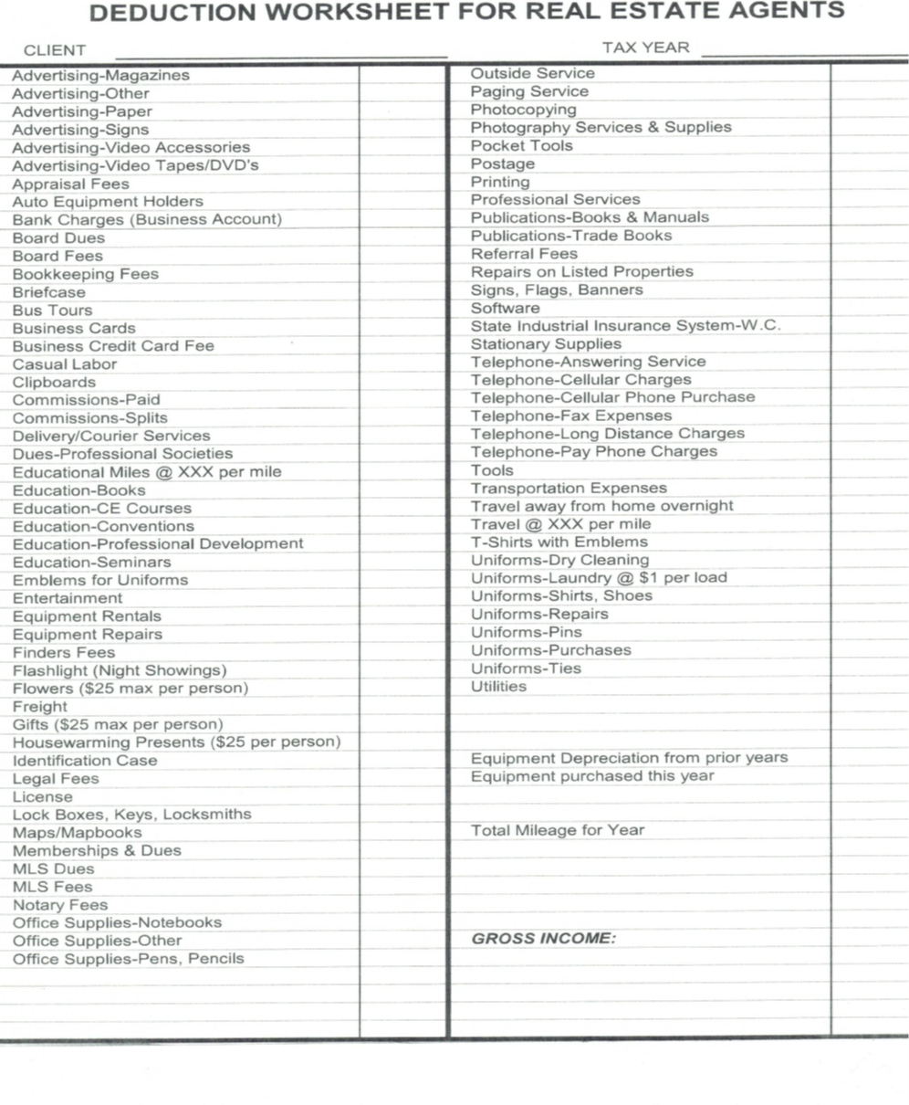

CONSENT FOR DISCLOSURE OF TAX RETURN INFORMATION

Federal law requires this consent form be provided to you. Unless authorized by law, we cannot disclose, without your consent, your tax return information to any third party. The law does authorize disclosure for purposes of preparation and filing of the return, such as electronic filing. The law does not authorize disclosure for purposes of emailing you a copy of your income tax return. If you consent to the disclosure of your tax return information, federal law may not protect your tax return information from further use or distribution.

You are not required to complete this form. If we obtain your signature on this form by conditioning our service on your consent, your consent will be invalid. If you agree to the disclosure of your tax return information, your consent is valid for the amount of time you specify. If you do not specify the duration of your consent, your consent is only valid for one year from the date on the form.

Please complete: (To be completed by the taxpayer)

Purpose for forwarding information:
_______________________________________________________________________________________________________________________________________________________________________________________________________________

Name and address to whom the information is being disclosed to:
_______________________________________________________________________________________________________________________________________________________________________________________________________________

Duration of Consent: ____________________________________________________

I, ___________________________________, authorize Tidewater Accounting & Bookkeeping Services, Inc. to disclose to _________________________________
my tax return information for the _________ tax year.

Signature: _________________________________ Date: ____________________

If you believe your tax return information has been disclosed or used improperly in a manner unauthorized by law or without your permission, you may contact the Treasury Inspector General for Tax Administration (TIFTA) by telephone 1-800-366-4484 or by email at complaints@tigta.treas.gov.

